Objective: The objective of completing a 10 Elements Gap Analysis is to help you conduct a very high level review of any existing agreement(s) with the intent to help you identify any structural flaws in the architecture of your agreement.
Resources: Use the free online 10 Elements Self-Assessment through this link. We also recommend augmenting the online assessment by using the Contract Review Quick Guide at the end of this document to identify gaps in any existing agreement(s).
Tip! Many organizations find it helpful to work with a Vested Center of Excellence to perform a formal Deal Review of an existing agreement. You can learn more about a Deal Review by using this link.

10 Elements Self-Assessment
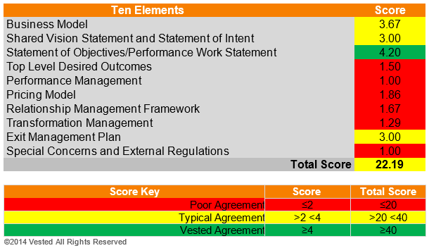
The 10 Elements Self-Assessment will help you gauge how well you are applying each of the 10 contractual elements of a Vested Agreement in your organization. This assessment is ideal if you have an existing agreement with a business partner. Use this link to complete the online self-assessment. You will get an email back promptly (typically within 5 minutes) that provides a summary as well as a high level diagnostic of your agreement. The assessment is color-coded to highlight the magnitude of the gaps, with red meaning you have large gaps you will need to close.
If possible, we recommend having your key stakeholders complete the survey (an open source Stakeholder Analysis tool is available to help you). The survey is 47 questions and completing it typically take less between 10 and 15 minutes. Having the stakeholders complete the self-assessment will give you a feel for how well the stakeholders perceive any existing agreement is working. We find that stakeholders often have a wide range of opinions of how well your organization is “living” the more important attributes.
Tip! To complete as a group, have each of the stakeholders who took the assessment forward their results to a designated person who can compile all of the results. Gather all responses of the 10 Elements Self-Assessment and develop a summary from the responses. A good way to do this is to:
- Plot the scores to identify the variances in people’s perceptions.
- Compare the range of responses to the average.
- If both you and your partner are taking the assessment, compare your results with the goal to create a deeper discussion around how to close the gaps. The Exhibit below shows a real example of how two companies (in this case a company and service provider) got the discussion started by sharing and discussing the results.
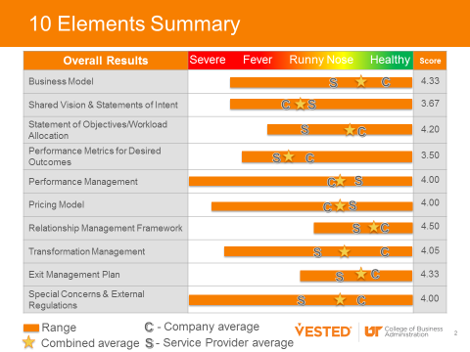
Tip! A University of Tennessee faculty member will be happy to compile a customized report for your organization for $500 – with all proceeds going to the Vested Research Fund. Click here to email a faculty member and inquire about how to get a customized assessment report launched.
Contract Review Quick Guide
Many organizations find it useful to augment the 10 Elements Self-Assessment by completing the Contract Review Quick Guide. The Contract Review Quick Guide is an easy to use checklist of 84 Vested criteria at the end of this document. Use the Contract Review Quick Guide (starting on page 4 of this document) to determining if your organization has completely implemented, partially implemented or not implemented each attribute. Once completed, the Contract Review Quick Guide will show specific gaps by each of the Vested 10 Elements. It can be used as a roadmap for improvement as you start to create your Vested Agreement.
Tip! A University of Tennessee faculty member will be happy to complete an objective contract review for your organization. In addition, many organizations find great value in having a Vested Center of Excellence complete a comprehensive “Deal Review” that includes a rigorous review of not only the contract, but all aspects of your relationships. Click here to email a faculty member to learn more.
Developing a Roadmap for Your Vested Journey
Identifying gaps is important, but closing them is a key for success. Many companies like to develop a “Roadmap” that will help them visualize the work that needs to be done. In most cases, organizations move forward and do a complete structuring of their potential agreement using the Creating a Vested Agreement online course. However, in some cases organizations choose to close gaps over time – prioritizing which elements they want to address first. If this is your situation, we recommend using the Vested Journey Roadmap PowerPoint Template (provided as part of the Vested Open Source Toolkit you have downloaded) to convey your strategy. The below example shows how one company prioritized implementing each of the 10 Vested Elements.
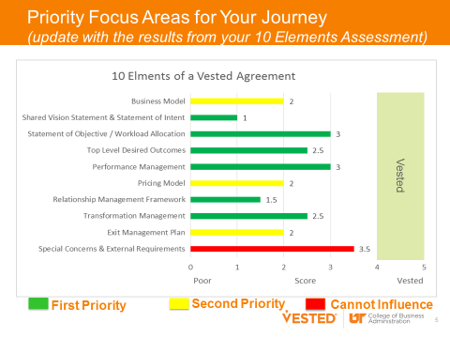
Complete | Partial |  | None |  | Vested Quick Guide®
Master Services Agreement
 |  |  |  |  | MSA is small in size, referencing business aspects in Exhibits
 |  |  |  |  | MAS language can support multiple SOOs if required
 |  |  |  |  | Flexible MSA structure referencing all 10 Vested Agreement Elements in Exhibits
Rule 1: Outcome-Based vs. Transaction-Based Business Model
Element 1 |  |  |  |  | Business Model
 |  |  |  |  | Business model relationship map shows alignment of attributes with Vested business model
 |  |  |  |  | Gaps in business model have been addressed
 |  |  |  |  | Shared value has been identified (Pony)
 |  |  |  |  | The business model supports the Desired Outcomes
Element 2 |  |  |  |  | Shared Vision Statement and Statement of Intent
 |  |  |  |  | A Shared Vision and Statement of Intent is included in the formal agreement
 |  |  |  |  | Intentions include all seven components (Shared Vision, communication, perspective, trust and confidence, flexibility, focus, and feedback)
 |  |  |  |  | Intentions are aligned to the Shared Vision Statement
 |  |  |  |  | Intentions establish how the parties will behave and makes a WIIFWe commitment
 |  |  |  |  | Intentions recognize the service provider as a partner in success
 |  |  |  |  | The Shared Vision Statement is restated in meetings and joint communications
Rule 2: Focus on the WHAT, not the HOW
Element 3 |  |  |  |  | Top Level Desired Outcomes and Statement of Objectives
 |  |  |  |  | The agreement includes Desired Outcomes and Statement of Objectives (SOO)—not a statement of work (SOW)
 |  |  |  |  | Company and service provider developed the Desired Outcomes/SOO jointly
 |  |  |  |  | Objectives are clearly aligned to Desired Outcomes
 |  |  |  |  | SOO defines what work is to be performed not how to accomplish the work
 |  |  |  |  | The Service provider may have developed a Performance Work Statement (optional deliverable)
 |  |  |  |  | Workload Allocation is included in the agreement
 |  |  |  |  | Parties have completed a taxonomy of work to be performed (Workscope )
 |  |  |  |  | Parties have allocated work through total cost and a best value assessment
Rule 3: Clearly Defined and Measurable Desired Outcomes
Element 4 |  |  |  |  | Performance Metrics for Desired Outcomes / Requirements Roadmap
 |  |  |  |  | Outcomes are expressed as a limited set of high-level metrics
 |  |  |  |  | Metrics were developed collaboratively
 |  |  |  |  | Metrics definitions, calculations, data source and frequency are documented in the agreement
 |  |  |  |  | Metrics include tolerances and/or targets
 |  |  |  |  | Achievement of metrics is validated through a mutually agreed to Quality Assurance Plan

Complete | Partial | None | Vested Quick Guide®
Element 5 |  |  | Performance Management
 |  |  | Performance reporting process is documented in the agreement
 |  |  | Parties have joint ownership for performance management
 |  |  | Dashboards consisting of Key Performance Indicators (KPI) are used and frequently updated
 |  |  | Metrics reports are used as part of regular review meetings across all functions/all levels
 |  |  | Reporting and review frequency is documented in the agreement
 |  |  | Root cause analysis is used to drive process improvements
Rule 4: Pricing Model Incentives are Optimized for Cost/Service Tradeoffs
Element 6 |  |  | Pricing Model (Margin Matching Frameworks/ Incentives Framework)
 |  |  | The pricing model was developed jointly
 |  |  | Both parties established and share guardrails
 |  |  | Guardrails are documented in agreement
 |  |  | The parties have documented input assumptions
 |  |  | Total Ownership Costs and Best Value was assessed
 |  |  | Risks were assessed and allocated fairly
 |  |  | Risks were assessed using a formal process (5-steps)
 |  |  | Costs of Risks were identified and a risk premium established if needed
 |  |  | Risks are allocated to the party best able to mitigate them
 |  |  | The parties agreed on the compensation model
 |  |  | The contract duration allows for reasonable recovery of investments
 |  |  | Parties jointly develop a pricing model
 |  |  | A joint P&L is used to provide transparency (may develop individual P&Ls that are shared)
 |  |  | The pricing model is directly tied to achieving Desired Outcomes (including performance and cost objectives)
 |  |  | The pricing model is based on fixed cost, cost reimbursement or a hybrid of the two
 |  |  | Governance is “paid for” in the pricing model
 |  |  | The pricing model includes a “fee at risk” earned based on meeting performance objectives (optional attribute)
 |  |  | The pricing model is flexible and can be changed as business conditions warrant
 |  |  | The pricing model fosters improvement and innovation
 |  |  | The pricing model baseline is documented
 |  |  | The pricing model, including assumptions and potential risk impact, was tested
 |  |  | Margin-Matching triggers and techniques are defined and used to adjust baseline as business happens
 |  |  | Incentives are incorporated into the pricing model
 |  |  | Incentives are tightly aligned to Desired Outcomes promoting behaviors and outcomes that benefit the parties
 |  |  | Incentive frameworks are in place to measure performance and trigger incentive awards or payments
 |  |  | Value sharing vs. gainsharing is used (the parties look beyond cost savings to include the change in the total value the solution brings to the company)
 |  |  | Cost incentives reward for reductions in costs (optional incentive method)
 |  |  | Performance incentives reward for improved performance (optional incentive method)
 |  |  | Non-monetary incentives may be used (optional incentive method)

Complete | Partial | None | Vested Quick Guide®
Rule 5: Insight vs. Oversight Governance Structure
Element 7 |  |  | Relationship Management Framework
 |  |  | Include a tiered management and governance structure
 |  |  | Include separate service delivery, transformation and commercial management roles
 |  |  | Peer-to-peer communication protocols in place
 |  |  | A well-defined communications cadence, tempo or rhythm
 |  |  | A documented process to maintain continuity of resources, including onboarding of new team members
 |  |  | A joint performance management program
Element 8 |  |  | Transformation Management
 |  |  | Change management plan is documented
 |  |  | Both parties actively use change management process for updating and managing any changes to the actual agreement
 |  |  | Transformation Process jointly defined, agreed and documented
 |  |  | Process in place for driving overall transformation initiatives
 |  |  | A formal joint continuous improvement program documented
 |  |  | Process for managing day-to-day continuous improvement efforts or business problems is institutionalized
 |  |  | Well-defined transition plan (optional deliverable)
Element 9 |  |  | Exit Management Plan
 |  |  | Adequate exit criteria, and equitable on and off ramps for both parties
 |  |  | Termination notice process in place
 |  |  | Documented exit transition period
 |  |  | Exit transition plan is outlined or parties have agreed to the key elements in advance
 |  |  | Exit governance and reporting plan is documented
 |  |  | Exit transition manager and exit management team are identified (by roles)
Element 10 |  |  | Special Concerns and External Requirements (some of these may be in the MSA)
 |  |  | Special concerns and external requirements are clearly vetted and understood by both parties
 |  |  | Special conditions are documented within the master services agreement
 |  |  | Standard regulations, laws, industry standards, etc. are incorporated by reference and not replicated in the agreement
 |  |  | Agreement defines who is responsible to track changes and updates to external regulations, laws, standards, etc.

This document is provided as part of the Vested “Open Source Material.” “Open Source Material” includes the Vested Orientation Course and associated PowerPoint slides, items in the Open Source “Toolkit,” and the ability to redistribute any of our white papers and case studies contained in our Vested library, as well as the ability to redistribute The Vested Way eBook.

We encourage you to share some or all of the Vested Open Source Material pending compliance with the following distribution guidelines and terms of use:

- Please do not alter any Open Source Material in terms of the template, background, colors, or the Vested images used.
- If you use Open Source Material in your own document, you must provide the following attribution: “Source: Used with permission. Vested® www.vestedway.com. Vested, Inc.”
- Always write the word “Vested” with an uppercase “V.”
- Please use the word “Vested” throughout any presentation, except where you are referring to the outsourcing industry, in which case the words “Vested Outsourcing” may be used.
- Please do not abbreviate “Vested Outsourcing” as “VO.”
- Please do not commercially sell, rent, or profit from the use of this Open Source Material unless Vested Outsourcing gives you explicit prior written permission to do so.

The complete terms of use is located at http://www.vestedway.com/terms-of-use-agreement-open-source-material/

If you would like to use this material for commercial purposes / for profit basis, please contact Kate Vitasek at kvitasek@utk.edu.

