Objective: The objective of Requirements Roadmap Template is to help you build stakeholder consensus around your Desired Outcomes and to help you create a “Roadmap” that will clearly define and measure each of the Desired Outcomes.
Tip! Organizations adopting Vested for larger or more complex agreements may find it useful to engage a Vested Center of Excellence to help facilitate the development of your Requirements Roadmap. A typical Requirements Roadmap facilitated workshop includes a cross-functional group of stakeholders and takes two days to complete.

“Using the Requirements Roadmap was great. After we completed that tool, I used it more than anything else when writing the contract. I can’t tell you how many times I referred to it when we were writing the contract, because it really is the heart of the contract.”
- Darrin Browder, Vested Certified Deal Architect, Strategist and Supplier Relationship Manager - Dell, Inc.,

Getting your requirements right is essential for any business agreement. A Vested Agreement uses the Requirements Roadmap Template to help business partners clearly define requirements. A well-defined Desired Outcome:
- Is linked to your Shared Vision
- Is clearly stated
- Is often boundary spanning – and not something that the service provider can accomplish on their own
- Is most often measurable, even if measuring it is somewhat vague (see Green and Clean from module 5 of the online courseware or chapter 7 from The Vested Outsourcing Manual)
- Is linked to achieving your strategic objective
- Is not a task oriented SLA (Service Level Agreement) found measuring an activity or an “output” as typically found in conventional buyer-supplier agreements

Defining your Desired Outcomes is a JOINT exercise with key stakeholders present and is best if done in a face-to-face setting, allowing direct dialog.

Tip! This exercise is well-suited to be conducted in a larger “facilitated workshop” environment with the goal to allow as many people as possible to have input and gain buy-in about what the parties intend to accomplish going forward. Many find that combining this exercise with the Shared Vision exercise from the Module 4 of the Creating a Vested Agreement online course a valuable use of key stakeholders time. If you have an existing supplier, the partner should be part of this exercise. If you are creating a Requirements Roadmap as part of a Vested Request for Partner process, your short list of selected service providers should be invited to participate in the workshop.

As you complete the Requirements Roadmap Template – you will work from left to right, first completing the Desired Outcomes and the Statement of Objectives (SOO) columns.

Step 1: Complete the Desired Outcomes and SOO Columns of the Requirements Roadmap Template

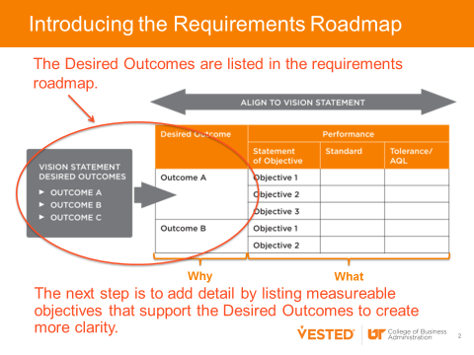
Start by “brainstorming” potential Desired Outcomes; there should be no limits.
- Develop a consensus view by consolidating and agreeing on a limited number of Desired Outcomes (typically 3 – 5, but definitely no more than 7)
- Take a look at your Desired Outcomes based on these questions
  - Do your Desired Outcomes support your strategic direction?
  - Do your Desired Outcomes emphasize your strategic direction with regards to:
    - Cost?
    - Schedule?
    - Performance?
    - Customer satisfaction?
    - Other?

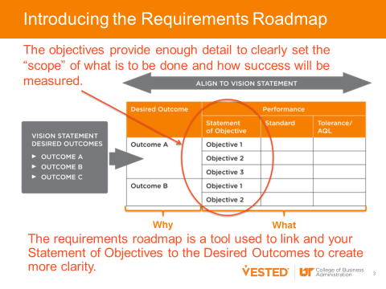
- Expand each Desired Outcome into a few objective statements. Note: often many of the initial Desired Outcomes you identified become Objectives that fall under a broader Desired Outcome.
  - Objectives should be clearly stated
  - Objectives should support the Desired Outcome
  - Objectives should be measurable, even though you may not have the data to measure the objective at this time. A measurable objective can be measured as a “yes/no” and not by a number.
- If you have identified metrics associated with your Objectives, go ahead and fill those in under “Standard” and “Tolerance.”
- Once you are happy with your Desired Outcomes and Objectives, adjust the statements, if necessary, to assure that they are quantitative and in support of overall strategic direction.

Step 2: Complete the Standard and Tolerance Columns of the Requirements Roadmap Template
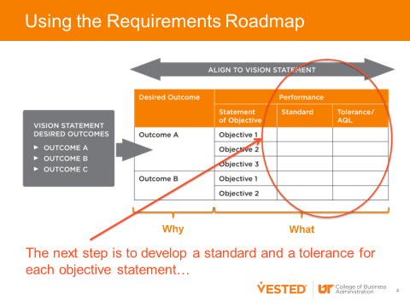
It is critical to know how you will measure your Desired Outcomes. Metrics will be used by both organizations to measure progress against the Desired Outcomes. This will involve:
- Agreeing on and documenting a standard or the targeted level of performance that you jointly agree is acceptable. A standard is the targeted level of quality or performance that stakeholders would generally consider normal or acceptable.
- Agreeing on and documenting any tolerance. A tolerance is the amount by which performance can be different from the standard before it is no longer acceptable. For example, in a supply chain agreement the standard might be a 99% fill rate and the tolerance might be 97% to 99.7% (achieving below 97% impacts customer satisfaction and achieving more than 99.7% is an indicator of holding too much inventory).
Once you have updated the Requirements Roadmap Template, ask the following questions:
- Have you established performance standards and tolerances for each SOO? If you still have work to do, have you included a placeholder in the requirements roadmap?
- Can you clearly link the standard back to the Desired Outcome?
- Have you determined which of the objectives and associated performance standards the service provider is accountable for and which the company is responsible for? Note: in many cases metrics are boundary-spanning. This is appropriate.
- Is the standard clear? Are the tolerances clear and fair?
- Do you have too many or too few measures?

Step 3: Complete the Quality Assurance Plan Columns of the Requirements Roadmap Template

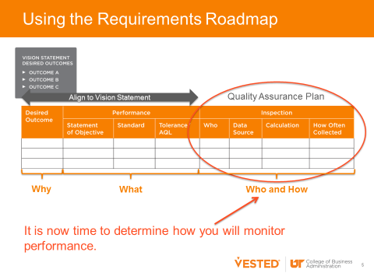
The Quality Assurance Plan portion of the Requirements Roadmap ensures agreement on how you will monitor success. Each performance statement includes four things:
- Who is responsible for the data related to the metric? List the department responsible.
- What is source of the data? Be specific so that it is clear what data is used and where it is located.
- How is the metric calculated? Clearly document the formula used to calculate the metric. If the metric relies on other reported metrics, take the time to validate and document these calculations.
- How often is the data collected? Clearly establish how frequently the data is collected and the metric calculated and when is it reported and reviewed.
Once you have updated the Requirements Roadmap Template ask the following questions:

- Have you clearly documented the quality assurance plan for each objective statement?
- Are all parties in agreement?
- Is the frequency of collection and reporting sufficient to manage performance?

Tip! Don’t forget to review your Stakeholder Analysis and Communications Plan to see which stakeholders should review and have buy-in. If you have not worked with key stakeholders to complete this exercise, they will likely need to be debriefed and provided an opportunity to give their feedback.

Desired  Outcome | Performance |  |  | Incentive | Inspection
 | Statement of Objective | Standard | Tolerance/  AQL |  | Who | Data Source | Calculation | How Often Collected

This document is provided as part of the Vested “Open Source Material.” “Open Source Material” includes the Vested Orientation Course and associated PowerPoint slides, items in the Open Source “Toolkit,” and the ability to redistribute any of our white papers and case studies contained in our Vested library, as well as the ability to redistribute The Vested Way eBook.

We encourage you to share some or all of the Vested Open Source Material pending compliance with the following distribution guidelines and terms of use:

- Please do not alter any Open Source Material in terms of the template, background, colors, or the Vested images used.
- If you use Open Source Material in your own document, you must provide the following attribution: “Source: Used with permission. Vested® www.vestedway.com. Vested, Inc.”
- Always write the word “Vested” with an uppercase “V.”
- Please use the word “Vested” throughout any presentation, except where you are referring to the outsourcing industry, in which case the words “Vested Outsourcing” must be used.
- Please do not abbreviate “Vested Outsourcing” as “VO.”
- Please do not commercially sell, rent, or profit from the use of this Open Source Material unless Vested Outsourcing gives you explicit prior written permission to do so.

The complete terms of use is located at http://www.vestedway.com/terms-of-use-agreement-open-source-material/

If you would like to use this material for commercial purposes / for profit basis, please contact Kate Vitasek at kvitasek@utk.edu.

