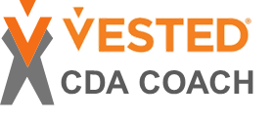
bv

CDA Coaching Program
Based on research with…
EXECUTIVE SUMMARY

The CDA Coaching Program is a continuing education program for the CDA Community. The primary purpose is a program that can keep all CDAs current. However, it also offers CDAs a path to become a Certified Vested Coach if they are interested.

The goal of the CDA Coaching Program is
“To create a system that continuously encourages and develops engaged and motivated CDAs who are actively growing the Vested movement globally.”

The program achieves this goal in three ways.
- Having a forum to develop and evolve content through continuous learning of the CDA community
- Having a platform to share content to help CDAs stay current
- Having a process to develop CDAs into Certified Coaches

A key part of the CDA Coaching Program includes helping CDAs understand the role, responsibilities, and mindset of what it takes to be a Vested Coach. For example, a Certified Coach must understand how to create an inclusive environment for collaboration and conflict resolution within Vested Partners and be able to help their organizations or clients successfully through a Vested journey from start to contract and beyond.

The program combines hard (technical skills on Vested) and soft (coaching) skills. Content includes positive experiences and examples and negative experiences and examples – both of which contribute to helping CDAs become better Coaches.

By reading this program overview, you can answer these questions:
- What are the obligations/time commitments of the CDA Coaching Program?
- What is the cost?
- What are the benefits?
- How can I become a Certified Coach?

Read the entire program overview to get a comprehensive understanding of the program. Or use Table of Contents to hyperlink to a focus area you are most interested in.

Table of Contents

CDA COACHING CONTINUOUS EDUCATION PROGRAM 4
Part 1: Overview of the CDA Coaching Program 4
Benefits of the CDA Coaching Program 4
Part 2: Eligibility and Requirements 4
Annual Cost of the CDA Coaching Program 4
Part 3: Platform to Share Content to Help CDAs Stay Current 5
CERTIFIED VESTED COACH PROGRAM 6
Part 4: Overview of the Certified Coach Program 6
Expanded Levels of Certification 6
Role Profile of a Certified Coach 7
Part 5: Eligibility and Benefits of the Certified Coach Program 8
Benefits of the Certified Coach Program 9
Part 6: Requirements to Become a Certified Coach 9
Part 7: Process to Develop CDAs into Certified Coaches and/or a Center of Excellence 10
Hard and Soft Skills Content and Delivery 10
Soft Skill Evaluation 11
Timeline to Earn Certified Coach Status 12
Closing Gaps in Soft Skills 12
On-going Requirements to Stay Certified 12
Part 8: Process for Commercializing 14
Part 9: Program Administration 15
Management of the CDA Coaching Program 15
Determination of the Initial Certified Coaches and CDA Coach Mentors 15
Accrued Incentive Program 15
Cost of the Certified Coach Program 15
Glossary 16

CDA COACHING CONTINUOUS EDUCATION PROGRAM

Part 1: Overview of the CDA Coaching Program
The CDA Coaching Program was developed by 11 CDAs representing CDAs in buying organizations, supplier organizations, independent consultants and CoEs. The goal was to develop a program to meet the needs of the evolving CDA Community. Many CDAs have asked about a continuing education program to keep their skills fresh. Others have expressed the desire to significantly expand their skills and perhaps become a “coach”, learning additional skills not currently offered under the existing CDA program. And still others have asked about how their organizations may be considered as a Center of Excellence.
The CDA Coaching Program is designed to:
- Provide a forum to develop and evolve content through continuous learning of the CDA community
- Create a platform to share content to help CDAs stay current
- Have a process to develop CDAs into Certified Coaches and if desired into a Center of Excellence

Benefits of the CDA Coaching Program
- Allows CDA's to stay current with the latest research and thought leadership and further develop their knowledge and skills
- Creates an opportunity for collaboration with peers with a structured way to share new knowledge within the CDA community

Part 2: Eligibility and Requirements
Any CDA may enroll in the CDA Coaching Program to keep their skills fresh; they need not pursue a Certified Coach designation to enroll in and benefit from the program. CDA’s wishing to become a Certified Coach must maintain enrollment in the CDA Coaching Program.

Annual Cost of the CDA Coaching Program
There is a $150 annual fee to participate in the CDA Coaching Program – this is cost recovery to maintain the program. Scholarships are available for individuals with special circumstances – to be approved by the Board of Advisors.

Part 3: Platform to Share Content to Help CDAs Stay Current
A key objective of the CDA Coaching Program is to provide a platform to share content to help CDAs stay current. The content includes a variety of topics designed to help CDAs be better CDAs as they support their organizations and clients in doing more Vested deals and/or relational contracts. It also includes positive experiences and examples & negative experiences and examples – both of which contribute to helping CDAs improve. The CDA Coaching Program will be delivered through the University of Tennessee/Vested Learning Management System via the CDA Coach Course. Content is delivered through a variety of learning on-demand, live virtual and in-person opportunities.

 | On-Demand | Live Virtual | In Person
Where/ How | - The Vested Learning Management System Platform (via the CDA Coach course)  - Go to www.VestedWay.com and log in to “My Account”  - Discussion board to which everyone contributes | - Virtual Deep Dive Sessions, Ask-the-Expert and Behind the Scenes Case Study sessions (one-hour sessions delivered via Zoom, Teams)  - Invitations to be sent out via email | - Annual CDA Conference  - Some CoEs offer regional events (e.g., Nordics has done this for 3 years)  - Specific courses (if there is demand)
Frequency | - Topics can be accessed anytime by simply logging into “My Account” and accessing the CDA Coach course | - Minimum once every two months  - Sessions are recorded for on-demand access | - CDA Conference is annual  - Other events vary

CERTIFIED VESTED COACH PROGRAM

Part 4: Overview of the Certified Coach Program

Expanded Levels of Certification
As part of the rollout of the CDA Coaching Program, the Board of Advisors also expanded the overall Vested Certification program into four distinct levels. The Certified Coach is the most advanced certification. In addition, two new certifications have been developed: The Foundation Certificate and the Practitioner Certificate.

The Vested Foundation Certificate covers the basics and is where most individuals learn the foundational knowledge of Vested, laying a strong base for any Vested journey and paving the way to all other certification levels. The Foundation Certificate has no prerequisites. Anyone with an interest in learning about Vested can take the required online courses for the Vested Foundation Certificate. A formal Certification Exam checks whether an individual can remember and understand the basic knowledge of Vested

The Vested Certified Practitioner encourages individuals working in a strategic relationship to gain a working knowledge of Vested without going through the rigor of becoming a Certified Deal Architect. The Certified Practitioner is ideal for individuals who want to move from “understanding” Vested to “applying” Vested in a real-world strategic business relationship.

Figure 1 (following page) highlights the basic differences between the Foundation Certificate, the Practitioner Certificate, the Certified Deal Architect and the Certified Coach.

Figure 1: Difference Between Certification Levels
Hard Skills/  Courses | - Orientation  - Five Rules  - Pass Certification Exam | - Is Vested Right for You  - Getting Ready  - 3-Day Vested Exec Education  - Creating a Vested Agreement  - Pass Certification Exam | - Courses for Practitioner  - Getting to We  - Collaborative Contracting  - UT Validation  - Pass Certification Exam | - Complete the Standing Neutral, Request for Partner, Relationship Health Monitoring, Delivering a CaT and Conducting a Deal Review Course Modules and pass quizzes  - Actively engaged in CDA Coaching Program
Applied Skills |  | - Participates on Deal Architect Team… or  - Plays a significant role post-contract implementation on a Vested Agreement | - Leads organization to complete Vested agreement  - Participates in a majority of implementation workshops  - Draft at least some parts of the contract | Demonstrates skills by  - Leading or facilitating at least two deals through the Vested methodology (one must be Certified)  - Leading SBM workshop  - Delivering a CaT  - Conducting a Deal Review  - Leading or facilitating an RFPartner process
Soft  Skills |  |  |  | - Passes CDA Coach Skills Assessment (average 4 out of 5 with no less than 3 on any skill)

If you have specific questions regarding the Certification levels, or would like additional information on any specific level, please contact us at VestedFaculty@UTK.edu.

Role Profile of a Certified Coach
A Vested Certified Coach encompasses a breadth and depth of advanced skills in applying Vested in real-world situations. These Vested gurus are actively involved in the CDA Coaching Program to keep their skills fresh. Certified Coaches:
- Are professional deal makers (e.g., consultant, lawyer, senior leader within an organization or other similar role) who work on multiple deals in their career.
- Have a broad understanding of Vested in practice and can evaluate how well a Deal Architect team is architecting their agreement; they can easily spot trouble with the design or implementation of a strategic partnership and is not afraid to critique the team and challenge them to make the appropriate decisions that may require one or both parties to change their status quo of how things have been done in the past.
- Can lead his organizations or facilitate her clients through an entire Vested process – helping them answer questions such as, “Is Vested the right Sourcing Business Model for my situation?”, “Is our organization ready for Vested?” and the literally hundreds of other questions Deal Architect Teams face in their course of implementing a Vested agreement. For example, Certified Coaches can successfully lead a Sourcing Business Model (SBM) workshop, interpret Compatibility and Trust Assessment results, perform a Deal Review that diagnosis structural flaws in an existing relationship, and can facilitate an organization through a Request for Partner process.

Part 5: Eligibility and Benefits of the Certified Coach Program
To become a Certified Coach Candidate, individuals must complete all of the Vested courses noted in orange in Figure 2, pass the CDA Certification Exam, enroll in the CDA Coaching Program and register for the Certified Vested Coach Course.

Figure 2: Required Course List

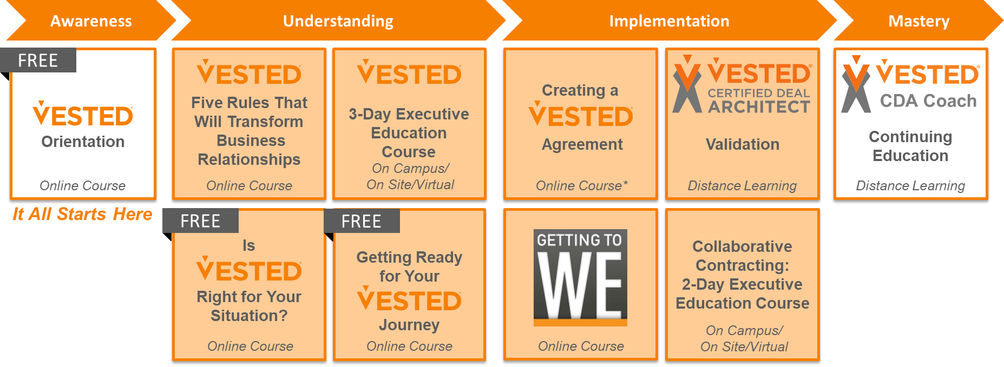

Are you an existing CDA looking to become a Certified Coach?
Individuals who completed their CDA before 2021 will have earned their CDA before some of the new courses were offered. It is recommended (but not required) these individuals take the new/revamped courses. However, they must pass the ‘hard skills’ requirements to become a CDA Coach which means passing the Practitioner Certification Exam.

Benefits of the Certified Coach Program
- Bridges the gap between CDA and COE, providing a clear and fair/equal process for CDA’s to become a Certified Coach
- Assures quality of Certified Vested Coaches for end customers
- Helps set the buyers (deal teams) of Vested consulting services expectations (clear guidelines on the skills of a Coach vs. a CDA)
- Provides an opportunity for CDAs/CoEs to differentiate based on the new skill levels/ certifications

Part 6: Requirements to Become a Certified Coach

 | Requirements |  | Pass Criteria
Hard Skills/  Courses | Enrolled in CDA Continuing Education Coaching Program and complete all Certified Coach Course Modules | - Standing Neutral  - Request for Partner  - Relationship Health Monitoring  - Delivering a CaT Assessment *  - Conducting a Deal Review * | - Pass each course module with a score of 80% or high
Applied  Skills | Application of key concepts in practice | - Leading or facilitating organizations through the Vested methodology | - Complete two deals; one must be a certified Vested deal
 |  | - Leading SBM workshop  - Delivering a CaT  - Conducting a Deal Review  - Leading or facilitating a Request for Partner process | - Demonstration application of each key concept (submit a brief record of an assignment in the CDA Coaching course)
Soft  Skills  Assessment | Demonstrates skills across 20 pre-defined soft “skills requirements” | See CDA Coach Skills Assessment Toolkit for the grading criteria and standards | - CDA Coach Candidates are evaluated by both their CDA Coach mentor and clients using the pre-defined skills requirement document  - Average 4 out of 5 with no less than 3 on any skill using the Soft Skills Assessment Toolkit
* Only available to those enrolled in the Certified Coach Course

Part 7: Process to Develop CDAs into Certified Coaches and/or a Center of Excellence
A key objective of the CDA Coaching Program is to develop CDAs into Certified Coaches and/or allow a clear path for organizations to become a Center of Excellence if desired.

Hard and Soft Skills Content and Delivery
The Certified Coaching Program helps CDAs develop both “hard” and “soft” skills assessment.
 | Hard Skills | Soft Skills
Content | Hard Skill Topics provide “deep dive” knowledge on Vested, such as:  - Case Studies (Behind the Scenes with team members)  - Profiles of Tools in Practice (e.g., examples of material used for Gates)  - Exposure to new tools and resources CDAs can use to improve their deals and/or skills  - Discussion Boards where members can get advice from their peers  - Drip campaign “e.g., Tip of the Week” | Soft Skill Topics provide CDAs with exposure to resources and tips that can help them improve their general coaching skills – these Topics include such things as:  - Facilitation tools and techniques  - Creative problem solving  - Collaborative negotiations  - Dealing with multiple stakeholders  - Role plays of how to communicate to people acting non-Vested  - Fist-to-Five techniques  - Online techniques and tools  - Standing Neutral skills  - Tips for putting Elephants in the Room  - How to deliver a Compatibility and Trust Assessment (CaT)
Delivery | Certified Coach Candidates ramp up their hard skills using virtual/online methods as much as possible – these include:  - On-demand learning sessions (Standing Neutral topic for example)  - Ask the Expert Discussion Board where CDAs can ask questions and get answers from UT Faculty and/or their CDA peers  - A mixture of 'expert' led and teams-based learning “live” sessions (delivered via Zoom)  - External courses recommended by the CDA Community (see External Course List to close gaps in skills) | Certified Coach Candidates will improve their soft skills by:  - Working with a CDA Coach mentor to close the gaps in their skills (as identified in a jointly developed Training Needs Analysis following a CDA Coach Skills Assessment)  - Hands-on experience applying these skills on a real project under the guidance of their CDA Coach mentor  - On-demand learning sessions to improve their general coaching skills (see Soft Skills Content Ideas)  - A mixture of 'expert' led and teams-based learning “live” sessions (delivered via Zoom)  - Courses offered by others (see External Course List to close gaps in skills)
Skills Assessment | - Pass all quizzes for CDA courses and Certified Coach courses with a minimum score of 80%. Individuals may retake the quizzes up to three times to pass.  - Complete the following essential Certified Coach Course Modules:  - “Standing Neutral”  - Request for Partner  - Relationship Health Monitoring  - Delivering a CaT Assessment  - Conducting a Deal Review | Complete a pre-defined and objective Soft Skills self-assessment and work with a CDA Coach mentor to ensure any gaps in soft skills are closed  - Average skills assessment score of 4 out 5 with no soft skill criteria scoring below a 3  See Figure 3 and the CDA Coach Skills Assessment Toolkit (on the following page) for the grading criteria and standards.

Soft Skill Evaluation
Soft skills are evaluated by the Certified Coach Candidate’s CDA Coach mentor. Certified Coach Candidates first fill in a self-assessment to identify skill gaps (See CDA Coach Skills Assessment attached below). Certified Coach Candidates are evaluated by their CDA Coach mentor using the CDA Coach Skills Assessment, and by their clients using the Client Assessment of CDA Coach Skills (attached below and also included in the CDA Coach Skills Assessment tool).

Figure 3: Soft Skills Grading Sheet
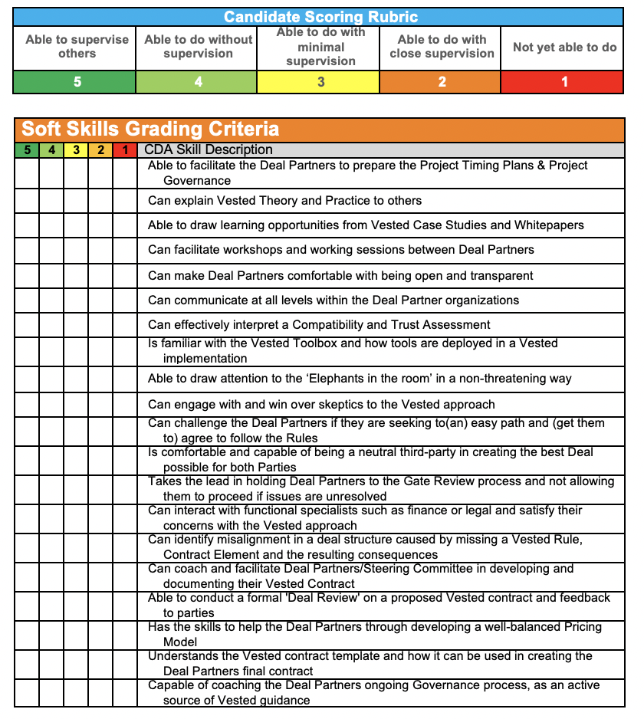

Timeline to Earn Certified Coach Status
The Certified Coaching Program is ongoing and there is no set timeline for moving from a CDA to a Certified Coach. Some CDAs may simply be involved in the CDA Coaching Program to be a better CDA and may never want to make the shift to a Certified Coach; that is perfectly OK because it still achieves the goal of the program, which is: “To create a system which continuously encourages and develops engaged and motivated CDAs who are actively growing the Vested movement globally.”

Closing Gaps in Soft Skills
Certified Coach Candidates collaboratively work with a CDA Coach mentor of their choice where they will be shadowed by their CDA Coach mentor who will coach them through a variety of situations until they can demonstrate proficiency as a coach themselves (e.g., pass the soft skills portion of the requirements). Once a CDA Candidate passes the hard and soft skills requirements, they “pass” as a Certified Vested Coach.

If a Certified Coach Candidate wants to become a Certified Coach and commercialize, they must select a CDA Coach mentor that is allowed to commercialize.

On-going Requirements to Stay Certified
Once someone becomes a Certified Coach, they will need to continue to keep their skills up to date. Like most certifications, the CDA Coaching Program requires a certain level of continuous education credits.
The CDA Coaching Program uses a flexible “point” system to make it easy for Certified Coaches to stay involved and focus on things they think are most appropriate for them:
- Certified Coaches must earn 10 total points of continuing education credit and/or equivalent leadership as a Certified Coach over a one-year period
  - 4 points must be earned by staying fresh on new content
  - The remaining 6 points can be earned in several ways

(see tables on the following page for options for earning points)

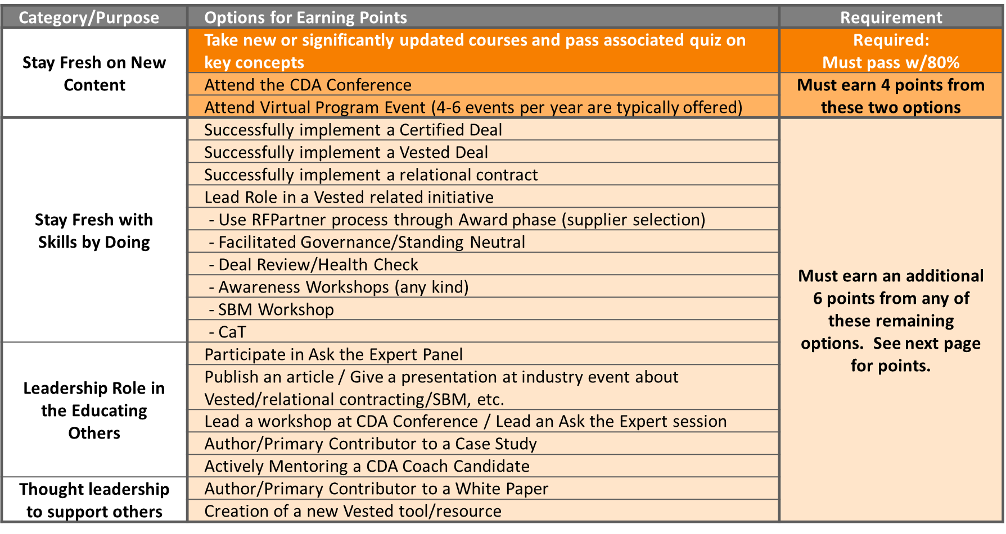

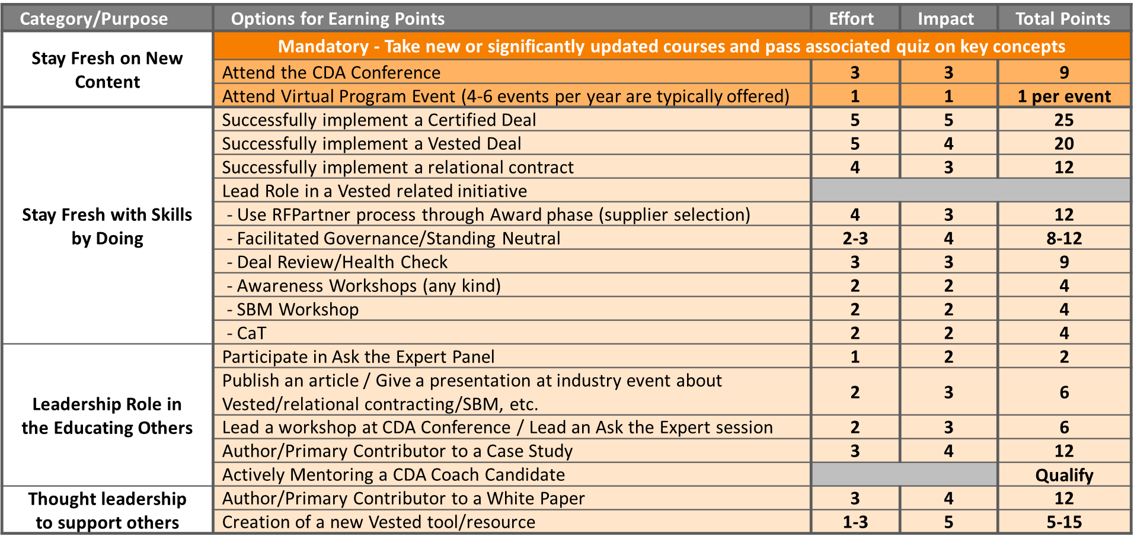

Part 8: Process for Commercializing
Individuals wishing to commercialize (sell Vested consulting services/use the Vested IP to make money) must have a license to commercialize.
- Individuals who work with a CoE are covered by the CoE’s license (e.g., employees or subcontracts to a CoE)
- Individuals who are not members of or subcontractors to a CoE and are wishing to commercialize must sign a Non-CoE Licensing Agreement, and work under the guidance of a CoE CDA Coach mentor to ensure quality/consistency
    - See the CDA Coach FAQs for additional information
    - See the Non-CoE Licensing Agreement for additional information
    - If your organization has one or more Certified Coaches on staff, they can apply to become a CoE. The Board of Advisors approves all applications for new CoEs.
- Individuals not wishing to commercialize need not sign a Licensing Agreement, and can choose any CDA Coach mentor.

Figure 4 provides a high-level summary.

Figure 4: High-Level Decision Matrix for Commercialization
 | CDA Coach Candidate | Certified Coach
CoE | - Needs to work with a CDA Coach mentor who is a member of his/her CoE | - Covered by company’s CoE Licensing Agreement
Non-CoE  Wishes to commercialize | - Needs to work with a CDA Coach mentor who is a member of a CoE | - Needs to sign a Non-CoE Licensing Agreement, and  - work under the guidance of a CoE for specific services in Table A (previous slide)  OR  - Become a CoE (and sign a CoE Licensing Agreement)
Non-CoE  Does not wish to commercialize | - Needs to work with a CDA Coach mentor who may or may not be a CoE  - No agreement required | - No agreement required

For questions on Commercialization and Licensing, reference this FAQ document

Part 9: Program Administration

Management of the CDA Coaching Program
The CDA Coaching Program is managed by the Vested Faculty, with oversight provided by the Vested Board of Advisors. UT Faculty lead the sessions, with Certified Coaches and CDAs actively participating to share their expertise with other members. We also have guest experts occasionally (e.g., such as Jim Groton for Standing Neutral). Sessions are open to all CDAs (buyers, suppliers, independents, COEs) and invited and approved guests (please contact Mike Watts with any invitation request).

Determination of the Initial Certified Coaches and CDA Coach Mentors
At the time of writing of this document, the CDA Coaching Program is new – which means at the program launch there are no formal Certified Coaches or CDA Coach mentors. However, several CDAs easily qualify as Certified Coaches. The CDA Coaching Program development team agreed on a simple process to certify the initial cohort of Certified Coaches as follows:
- Kate Vitasek will certify the initial Certified Coach Candidates she has worked with using the guidelines we have created
- Going forward, these Certified Coaches will become the mentors of new CDA Coach Candidates to certify additional Certified Coaches

Accrued Incentive Program
The original faculty behind the Vested movement had a vision to operates with a “grow the pie, share the pie” mindset. They created an IP holding company (VOI) which houses the Vested IP and issues licenses to commercialize. VOI has an expressed intent to share 20% of net profits (once VOI is profitable) with Vested Ecosystem members that contribute to the success of Vested. The mechanism to do this is an Accrued Incentive Program which rewards individual members of the Vested Ecosystem for thought leadership contribution. Incentive credits will be given when individuals contribute over the minimum of 20 points needed to stay certified each year.

Cost of the Certified Coach Program
There is a one-time enrollment fee of $500. In addition, Candidates and Certified Coaches must maintain enrollment in the CDA Coaching Continuous Education Program, at an annual cost of $150.

Glossary
These terms are specific to the CDA Coaching Program and are included for quick reference. For a complete listing of definitions, download the Vested Glossary, available in the Vested Library.

Certified Coach: A Vested Certified Deal Architect working to keep their skills fresh, and to lead his/her organization or facilitate her/his clients through an entire Vested process. Achievement of a formal certification from the CDA Coaching Program is required for the designation as a Certified Coach.

CDA Coaching Program: A system that continuously encourages and develops engaged and motivated CDAs who are actively growing the Vested movement globally.

Certified Coach Candidate: A CDA who has formally applied to become a Certified Coach, but has not yet achieved certification. The CDA Coaching Program is ongoing and there is no set timeline for moving from a CDA to a Certified Coach.

CDA Coach mentor: A Certified Coach who works with Certified Coach Candidates to help them close the gaps in their skills, and coach them through a variety of situations until they can demonstrate proficiency as a coach themselves.

Certification Exam: An exam that individuals must pass to earn a Vested Certification.

Certified Deal Architect® (CDA): A highly regarded certification designed for people responsible for strategic partnerships and supplier/client relationships. The program is modeled after a typical journeyman approach where individuals must apply their knowledge in practice.

Commercialize: Sell Vested consulting services, and/or use the Vested IP to make money.

Compatibility and Trust (CaT) Assessment: An anonymous 360⁰ relationship health assessment that measures relationship health across five dimensions. The CaT is administered by a CDA Coach that is fully trained and certified in using the Vested methodology. A CDA Coach Candidate must work with their CDA Coach mentor to conduct a CaT Assessment in order to be certified as a CDA Coach.

Deal Review: A formal, neutral third-party review conducted by a Certified Coach that is fully trained and certified in using the Vested methodology. Deal Reviews include reviewing a variety of “artifacts,” such as the contract, QBRs, scorecards, pricing model, etc., to identify key gaps in both the contract and the overall relationship. A CDA Coach Candidate must work with their CDA Coach mentor to perform a Deal Review in order to be certified as a CDA Coach.

Foundation Certificate: Covers the basics and is where most individuals learn the foundational knowledge of Vested, laying a strong base for any Vested journey and paving the way to all other certification levels. A formal exam checks whether an individual can remember and understand the basic knowledge of Vested.

License Agreement: Anyone who wished to commercialize Vested must sign a license agreement that gives them rights to use the Vested brand and affiliated IP.

Practice Quiz: An optional quiz available to individuals at the completion of a course to help them prepare for the Certification Exams.

Practitioner Certificate: This level of certification encourages individuals working in a strategic relationship to gain a working knowledge of Vested without going through the rigor of becoming a Certified Deal Architect. The Certified Practitioner is ideal for individuals who want to move from “understanding” Vested to “applying” Vested in a real-world strategic business relationship.

