Partner 1 – Partner 2 Statement of Intent
We collaborate with communities to elevate and transform the well-being of all – delivering personalized, exceptional experiences and results through innovative, equitable, and enduring solutions.
To achieve their mutual Shared Vision and high-level Strategic Objectives, Partner 1 and Partner 2 agree to follow six Guiding Principles. These Guiding Principles are the shared set of critical social norms and values that will guide the Parties in all dealings during the development of the partnership and any resulting contract that may stem from the partnership.
- Reciprocity: We make fair and balanced exchanges placing no expectation upon the other that we ourselves are not willing to return in kind.
- Honesty: We commit to an open, truthful and transparent working environment where positive intent is assumed and everyone is empowered to speak up, be authentic, and engage in candid conversations.
- Autonomy: While each partner remains free to exercise its discretion and act independently to advance our shared vision, neither party will promote its self-interest at the expense of the other.
- Equity: Each partner will benefit in proportion to the value, risk and contributions made to the relationship recognizing different organization starting points and different goals.
- Loyalty: Our partnership stands together through the good and the bad. We champion and protect the value of each other’s interests in the relationship as our own, extending grace, trust, and compassion in support of one another.
- Integrity: We dedicate ourselves to the highest ethical standards, demonstrated by consistently doing what is right even when it is hard.
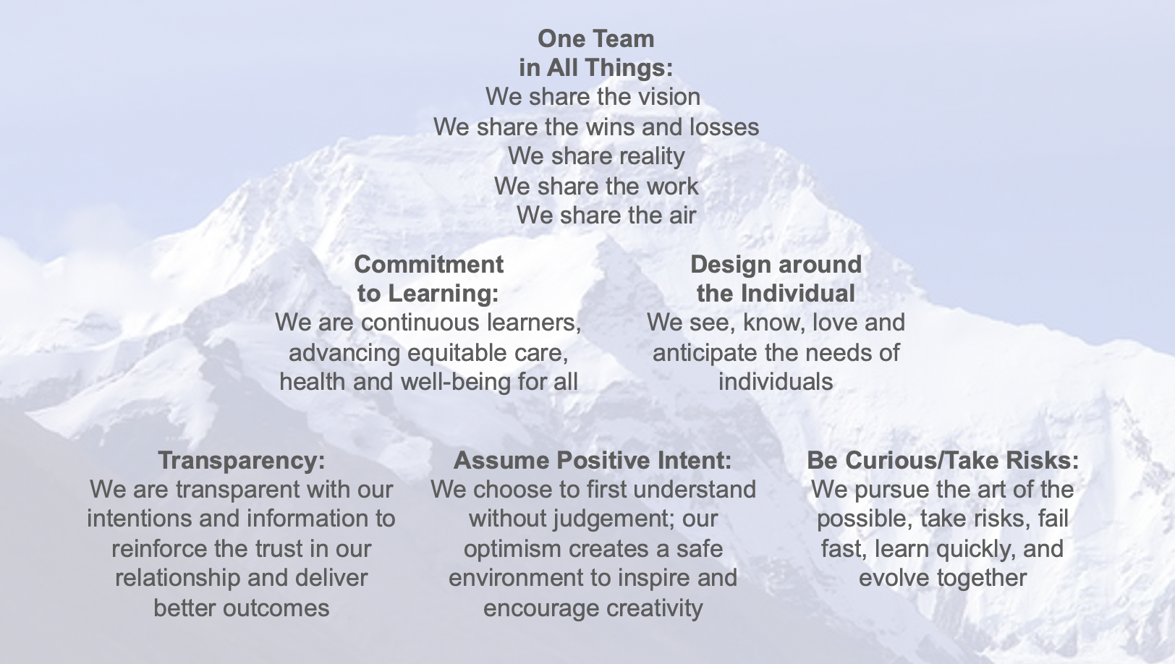
In addition to the Guiding Principles, Partner 1 and Partner 2 agree to foster an environment of trust, transparency, and compatibility. To achieve this both parties agree to proactively promote six Intended Behaviors to unite us under a One Team culture.

