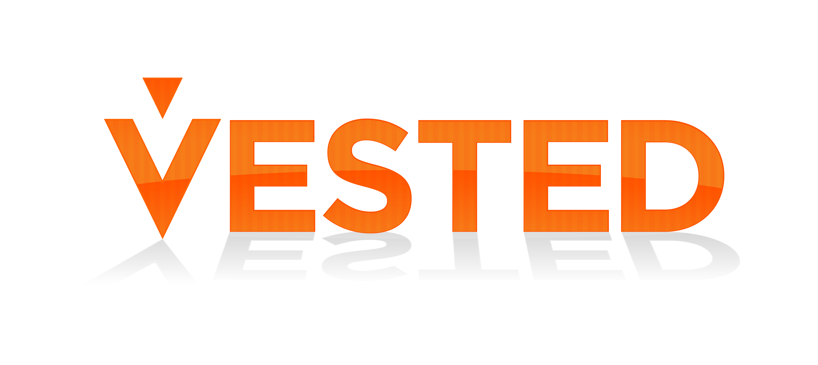
Five Rules that Will Transform Business Relationships

Vested® is a mindset, methodology, business model and movement for highly-collaborative, win-win relationships. A Vested sourcing business model combines a relational contract with an outcome-based economic model.
Vested is based on award-winning research conducted by the University of Tennessee and funded by the U.S. Air Force. UT researchers studied some of the world’s most successful business relationships–relationships based on true collaboration that achieved amazing – sometimes even thought of as impossible results. While each of the highly successful relationships was all unique – they all had a distinct mindset that promoted purposeful collaboration with the strategic intent to innovate, create value, and mutually reward success. Researchers called this a "What's in it For We" (WIIFWe) mindset.
While a WIIFWe mindset is at the heart of Vested, Vested embodies much more than just a mindset. Researchers codified the factors that created the environment for success into a business model named by World Trade Magazine as one of the “Fab 50+1” concepts impacting global commerce.

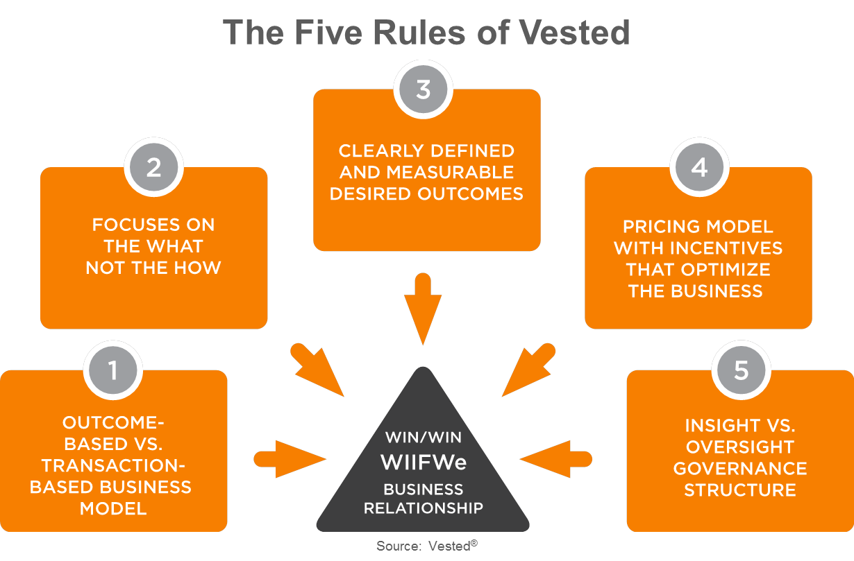
The Vested methodology leverages Five Rules – that when properly applied - have the power to drive transformational results. Together the rules create a hybrid business model that combines outcome-based, shared-value and relational economics principles. In a Vested environment, business partners seek to develop a common solution and a common bond based on mutual advantage to achieve Desired Outcomes.

Companies such as P&G, Microsoft, McDonald’s, and Dell are using a Vested sourcing business model and achieving “transformational” benefits. Their success stories are profiled in the book Vested: How P&G, McDonald’s and Microsoft are Redefining Winning in Business Relationships. While these examples are from the private sector – the process has also been deployed in public sector supplier relationship and investment-based deals (e.g. joint ventures) and labor union contracts.

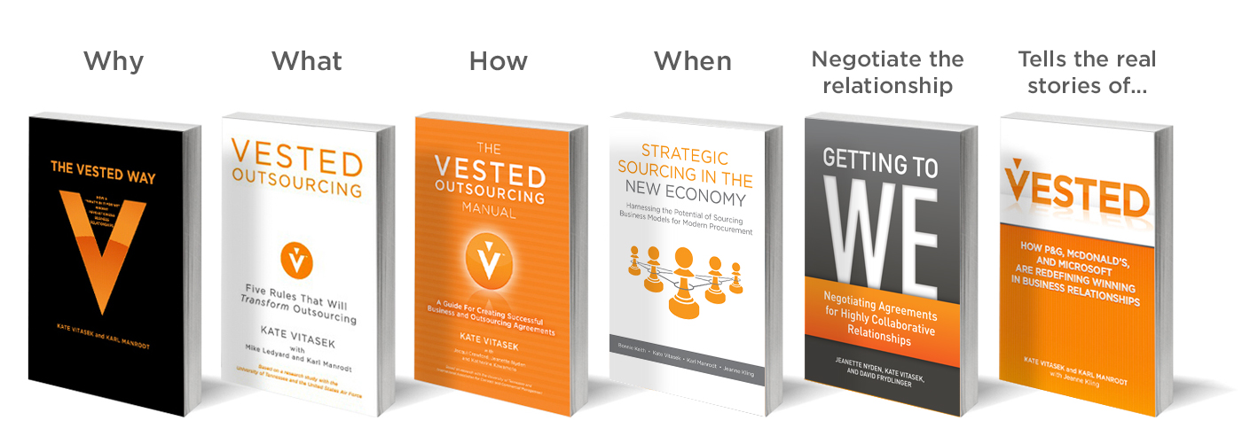
Want to learn more? Visit our dedicated website at www.vestedway.com or read one or more of our books on the topic. The University of Tennessee also offers a combination six online and onsite Executive Education course on Vested as part of our Certified Deal Architect program.

To learn more visit www.vestedway.com or contact Kate Vitasek at kvitasek@utk.edu

