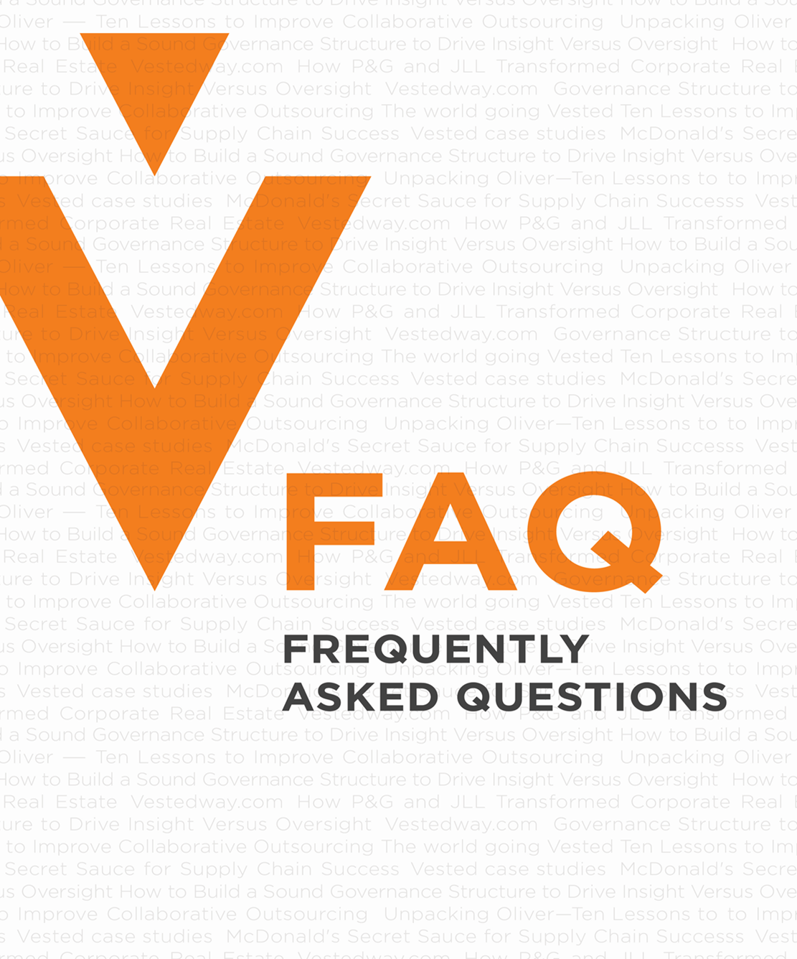
CDA Coaching Program
Commercialization, Licensing, etc.
CDA Coaching Program FAQs

Table of Contents
What do you mean when you say commercialization? 3
Can a Certified Coach commercialize? 3
What is a License Agreement and what does it cover? 3
Why is licensing for commercialization a special requirement for the Certified Coach program? 4
Does a Certified Coach have to commercialize? 4
Do all Certified Coaches have to sign a Licensing Agreement 4
Who has the authority to provide these specific Vested Services? 5
Does a CDA Coach Candidate have to be coached by a CoE CDA Coach mentor? 6
Can any Certified Coach become a CoE? 6
How do I determine which requirements apply to me? 6
Can you show me some examples for reference? 8

What do you mean when you say commercialization?
To commercialize means to sell Vested consulting services and/or use of the Vested IP to make money. Vested IP includes using the courseware, toolkits, templates or any branded documents.

Examples in Practice:
- EY commercializes on Vested when they have consultants that help their clients create a Vested Agreement.
- NEVI commercializes when they have a trainer deliver a Sourcing Business Model Workshop
- The Forefront Group commercializes when they deliver a Compatibility and Trust (CaT) Assessment and a CaT workshop.
- CI Advisory Services commercializes when they are asked to support a team who is working through a Request for Partner process they learned about in a white paper

If you have questions about what is means to commercialize, please email kvitasek@utk.edu.

Can a Certified Coach commercialize?
Yes, a Certified Coach can commercialize but he/she can only do this under the guidance of a CoE. Examples in practice include:
- A Certified Coach that is a member of or subcontractor to a CoE can commercialize
- A non-CoE affiliated Certified Coach that wants to commercialize must seek a CDA Coach mentor from a CoE.
- A non-CoE affiliated CDA Coach Candidate that does not want to commercialize can work with any CDA Coach mentor
- Certified Coaches must sign a license agreement unless they are working as a subcontractor or employee of a CoE. See additional questions for more information about licensing agreements/requirements.

What is a License Agreement and what does it cover?
Anyone who wished to commercialize must sign a license agreement which gives them rights to use the Vested brand and affiliated IP. There are two types of license agreements – a CoE Agreement and Non-CoE License Agreement.

The CoE Agreement and the Non-CoE Licensing Agreement are similar in that they allow individuals or organizations to use the Vested branding and IP for a license fee. A key difference is the Non-CoE Licensing Agreement requires the Certified Coach to work with an existing CoE for quality control. The agreement is attached.

Why is licensing for commercialization a special requirement for the Certified Coach program?
Prior to 2021, commercialization of Vested was only allowed by CoEs. A key goal of the CDA Coaching program is make the Vested IP more widely available. The CDA Coaching program offers Certified Coaches the possibility to commercialize with Vested IP without being part of a CoE. By requiring CDA Coach Candidates to work under the guidance of a CoE, quality standards for both the use of the brand/trademarks and in the quality of service delivery can be upheld.

Here is the logic behind why Certified Coaches must sign a license agreement.
- CoEs sign a formal CoE Licensing Agreement for the right to commercialize Vested IP. As part of the License Agreement they agree to uphold quality standards for both the use of the brand/trademarks and in the quality of service delivery.
- In essence, a Certified Coach who is commercializing is working in the capacity of a “CoE in training” and should be required to have the same quality standards as a CoE. For example:
  - CoEs cannot deliver a Vested service (e.g., a CaT) without having worked with someone to learn this particular service and skills.
  - CoEs are asked to always have two team members working on a Vested initiative, so having the CDA Coach Candidate work with their CDA Coach mentor is aligned with what we ask from CoEs. We would want the same for Certified Coaches who are starting to commercialize.
  - CoEs pay a license fee which is used to manage the Vested ecosystem and fund new research/products.
- Requiring Certified Coach who want to commercialize to sign a License Agreement and work under the Guidance of a CDA Coach mentor at a CoE helps ensure quality.

Does a Certified Coach have to commercialize?
No, a Certified Coach can decide for himself/herself whether he/she would like to commercialize using the Vested IP. However, if a Certified Coach decides to commercialize, then the commercialization guidelines apply and they must sign a License Agreement.

To clarify:
- A CDA has an unlimited individual lifetime license to all courses and can use any of the materials anytime free of charge for personal use within their organization. However, they would be required to have others in their company and their business partner(s) to take the courses so those individuals also have a license. Keep in mind tools are licensed via the various courses – three of the courses being free.
- A Certified Coach cannot commercialize on their own without being under the guidance of a COE or be a COE themselves

Do all Certified Coaches have to sign a Licensing Agreement
No, only the Certified Coaches who wants to commercialize have to sign a Licensing Agreement.

Who has the authority to provide these specific Vested Services?
Authority to Provide Services
 | VOI | CoE | Certified Coach Working Within Organization | Certified Coach with  Non-CoE License for Commercialization¹
University of Tennessee Executive Education Courses
Onsite / Virtual | X
Online | X
Awareness Support
Webinars, Awareness Workshop, etc.  using Open Source Materials² | X | X | X | X
Understanding Support
Online Free Self-assessments | X
Sourcing Business Model workshop | X | X | X | X
Self-assessment workshops | X | X | X | X
Deal Review |  | X | X | Under Guidance of CoE
Business Case Justification |  | X | X | X
Compatibility and Trust Assessment | X | X | X | Under Guidance of CoE or VOI
General Understanding Workshop (includes a variety of workshop topics such as Getting Ready, Request for Partner, Vested | X | X | X | Under Guidance of CoE or VOI
Implementation Support
Implementation Support  (e.g. facilitating companies through some or all of the Vested process ranging from Getting Ready through to crafting the agreement) |  | X | X | Under Guidance of CoE
Mastery
Facilitated Governance |  | X | X | Under Guidance of CoE³
Deal Certification (by approved UT Faculty only) | X
- Certified Coaches that are working as independent contractors (e.g., long term assignment of 12 months or more) are treated as a Certified Coach in an organization
- Anyone can provide Awareness support using the open source material as long as they are not commercialization (making money)
- For Vested Deals only – Governance for relational contracts can be facilitated without CoE Guidance

Does a CDA Coach Candidate have to be coached by a CoE CDA Coach mentor?
Yes, if a CDA Coach Candidate wants to commercialize (either immediately or in the future) he/she must work under the guidance of CoE CDA Coach mentor. Once a CDA Coach Candidate becomes a Certified Coach, he/she can request to become a CoE (which must be approved by the Board of Advisors) or he/she can continue to work in collaboration with an existing CoE.

No, if a CDA Coach Candidate decides not to commercialize, he/she can be coached by any CDA Coach mentor of their choice.

Can any Certified Coach become a CoE?
Yes, with the following considerations:
- He/she must be a Certified Coach for her organization to become a CoE: and
- His/Her organization would also need to sign a CoE Licensing Agreement which is similar but different from a Non-CoE Licensing Agreement: and
- All requests to become a CoE must be approved by the Vested Board of Advisors.

How do I determine which requirements apply to me?
The flowchart on the next page illustrates the steps in the process – just answer the questions and follow your responses.

The Path to Certified Coach

Can you show me some examples for reference?

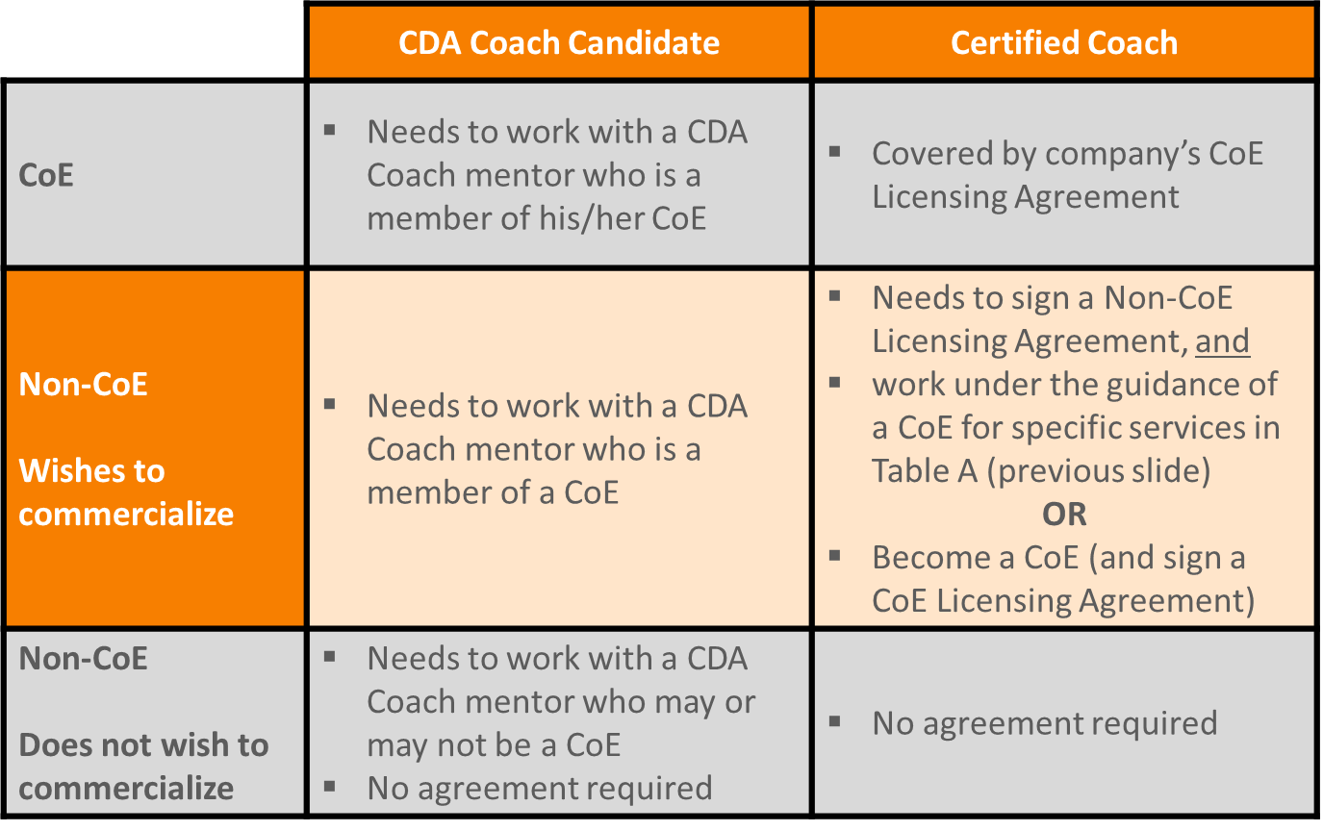
Scenario A
Situation: She is CDA that works for a buy-side company and her company allows her to work on side projects. She is a CDA Coach Candidate on these side projects.

Answer: She needs to sign a non-CoE agreement and work under the guidance of a CoE for specific services (reference Table A).

Scenario B
Situation: He is a CDA that owns his own company. He is a CDA Coach Candidate that would like to commercialize.
Answer: He needs to sign a non-CoE agreement and work under the guidance of a CoE for specific services (see Table A).

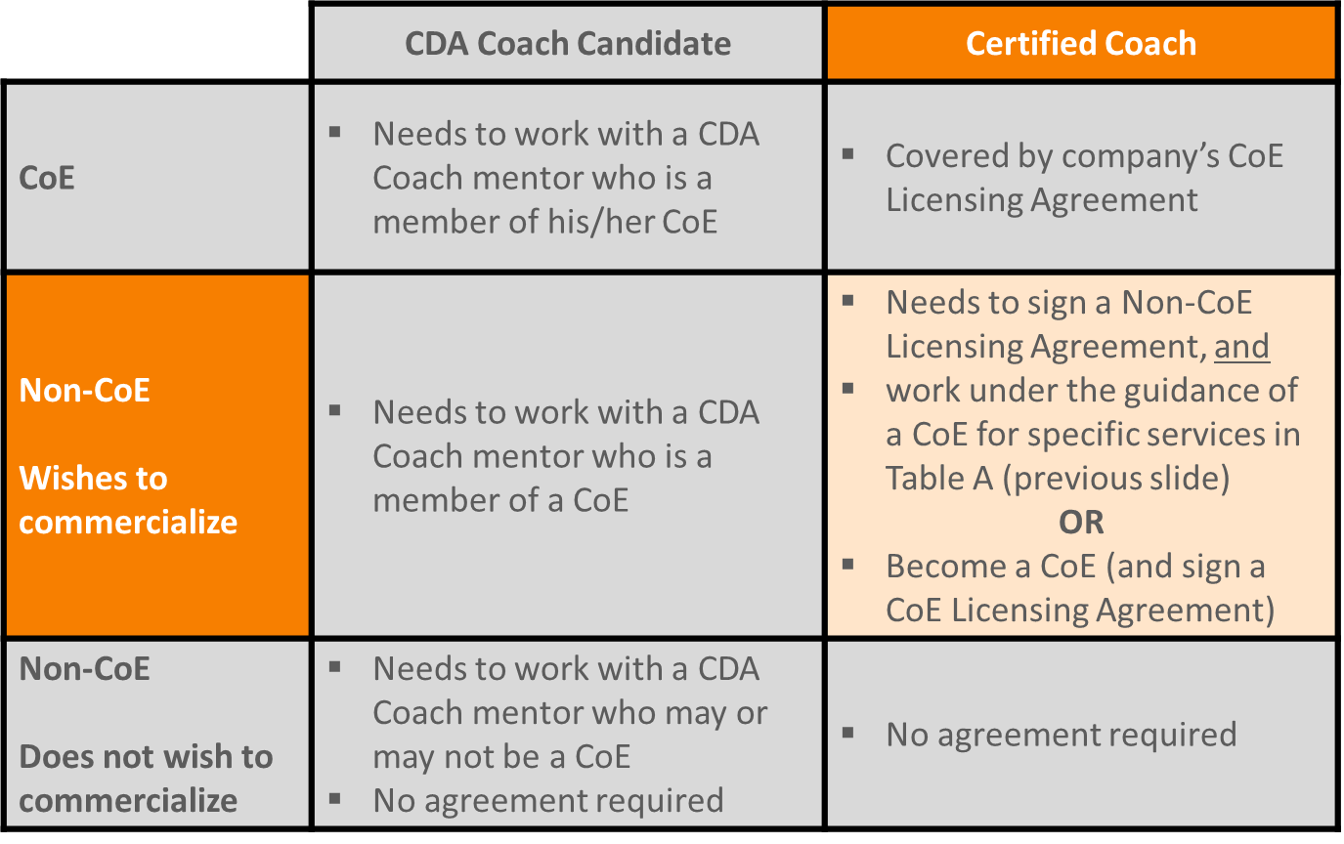
Scenario C:
Situation: She is a Certified Coach* with her own company and wants to commercialize.

Answer: She needs to sign a non-CoE agreement, and work under the guidance of a CoE for specific services (see Table A). Or she can opt to become a CoE and sign the CoE agreement. The Board of Advisors must approve her company as a CoE.

* For illustrative purposes of the example we have assumed she is a Certified Coach.

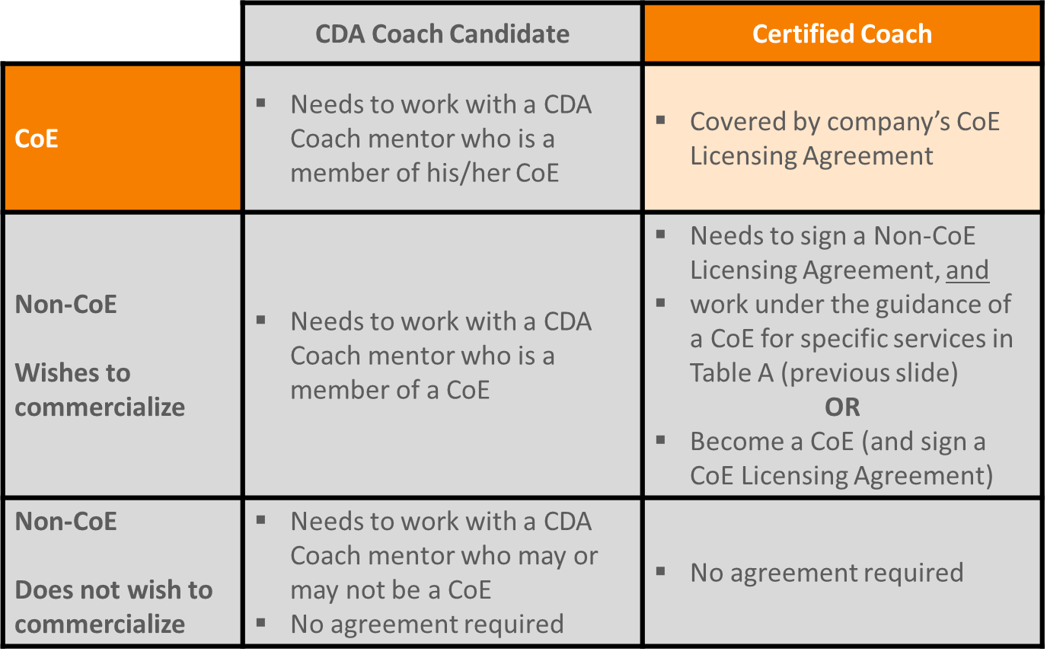
Scenario D:
Situation: A Certified Coach* working with a CoE, who wants to commercialize.

Answer: The CoE he is working with has already signed a CoE agreement, so he can commercialize and offer all of the services listed in Table A.

* For illustrative purposes of the example we have assumed he is a Certified Coach.

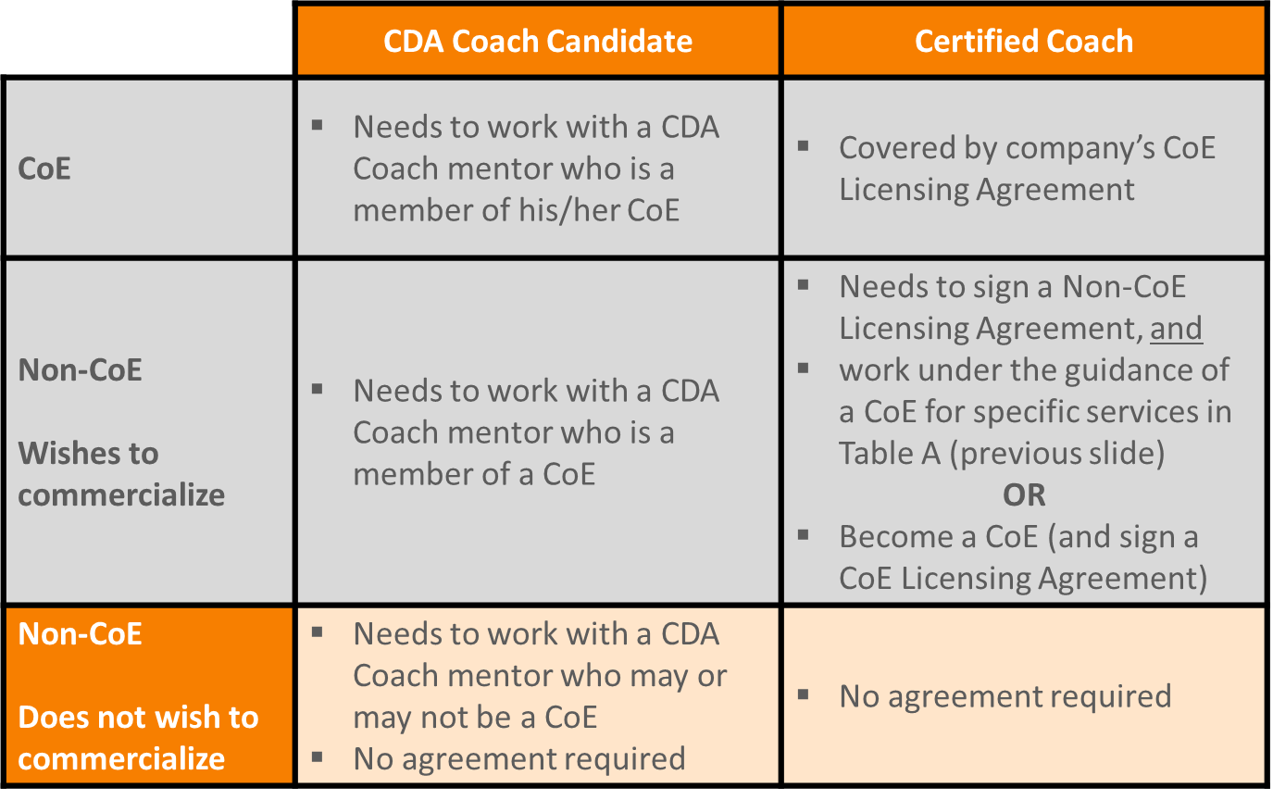
Scenario E:
Situation: She is a CDA that works for a sell-side company and is a CDA Coach Candidate. She does not want to commercialize.

Answer: She can work with a CDA Coach of her preference to become a Certified Coach.

Scenario F:
Situation: She is a CDA that recently left her position working for a sell-side company and is a CDA Coach Candidate. She is considering commercializing if the right project comes along.

Answer: She can work with a CDA Coach of her preference to become a Certified Coach. However, if she decides to commercialize she will need to sign a non-CoE agreement and work under the guidance of a CoE for specific services (see Table A).

Scenario G:
Situation: He owns a small boutique consulting firm and is currently collaborating with a CoE. He would like to commercialize as he is earning his CDA and he has aspirations to eventually become a Certified Coach.

Answer: He must complete all of the courseware and pass the quizzes to ensure he has the appropriate technical skills. In addition, he must sign a non-CoE licensing agreement and work under the guidance of a CoE for specific services (see Table A). He will need to complete the requirements for a CDA and Certified Coach before becoming a Certified Coach.

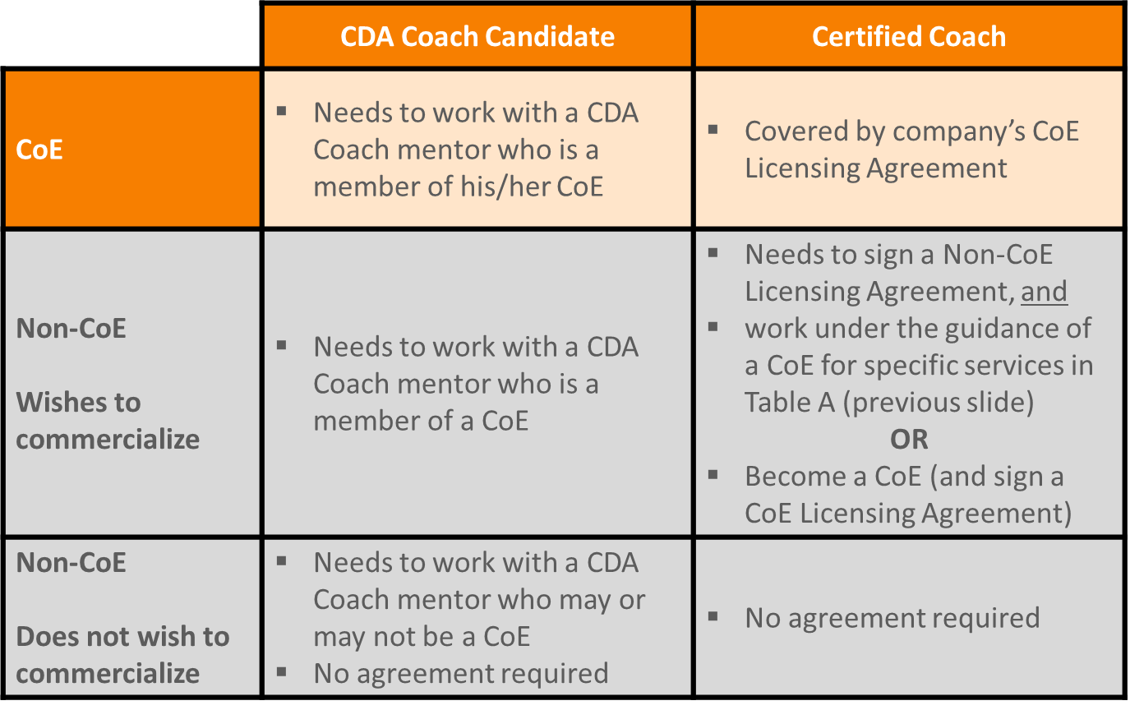
Scenario H:
Situation: He works as an employee for a CoE. He is just now going through the CDA Coaching program.

Answer: He can support an existing Certified Coach on a project without any requirements. However, it is highly suggested he completes all of the courseware and pass the quizzes to ensure he has the appropriate technical skills. He cannot become a Certified Coach until he has passed the requirements for a CDA and Certified Coach.

Scenario I:
Situation: He works as a subcontractor to a CoE, but also owns his own company. He is a Certified Coach that wants to commercialize.

Answer: He can work through the CoE for all Vested related services. If he wants to commercialize through his own company, he needs to sign a non-CoE agreement, and still work under the guidance of a CoE for specific services (see Table A). Or he can opt to become a CoE and sign the CoE agreement. The Board of Advisors must approve his company as a CoE.

